AutoEmail Delete AEF_LINK Records Tests
Tester: Tony Tasker
Date: 1st November 2016
Time: 12:40
PC/Server: TonyTasker-PC
Database: CABS_TEST (Copy of SHU DB)
Works Summary: N/A
Works Order: N/A
Task: N/A
Notes: Used a modified stored procedure to test which had a SELECT statement in rather than a DELETE statement for ease of testing
Pre-Test Setup
No | Task | Tester | Pass | Notes
1 | Ensure records exist in AEF_LINK  SELECT COUNT(*) FROM AEF_Link | TT |  | Returned 53
2 | In section CABS_AUTO_EMAIL_FUNCS_Trigger  Set DebugFlag=1 | TT
3 | In stored procedure CABS_AEF_DELETE_RECORDS comment out DELETE AEF_LINK … line and Re-Instate SELECT * FROM AEF_LINK … | TT

Post-Test Setup
No | Task | Tester | Pass | Notes
1 | In section CABS_AUTO_EMAIL_FUNCS_Trigger  Set DebugFlag=0 | TT
2 | In section CABS_AUTO_EMAIL_FUNCS_Trigger  Set AgedFunctionInDays = 0 | TT
3 | In stored procedure CABS_AEF_DELETE_RECORDS comment out line SELECT * FROM AEF_LINK … and Re-Instate DELETE AEF_LINK | TT

Tests

CABS_AUTO_EMAIL_FUNCS_TRIGGER Disabled Set to 0
No | Test | Tester | Pass | Notes
1 | In section CABS_AUTO_EMAIL_FUNCS_Trigger  Set Enabled = 0 | TT
2 | Step through stored procedure CABS_AEF_DELETE_RECORDS | TT |  | Returned from procedure as trigger is disabled

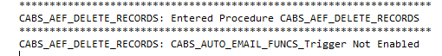
Figure 1 – Trigger Not Enabled Message

AgedFunctionInDays Set to 0
No | Test | Tester | Pass | Notes
1 | In section CABS_AUTO_EMAIL_FUNCS_Trigger  Set Enabled = 1 | TT
2 | In section CABS_AUTO_EMAIL_FUNCS_Trigger  Set AgedFunctionInDays = 0 | TT
2 | Step through stored procedure CABS_AEF_DELETE_RECORDS | TT |  | No records deleted as AgedFunctionInDays set to 0

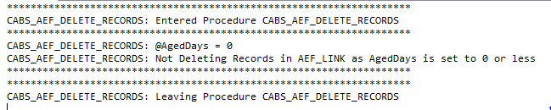
Figure 2 – AgedFunctionInDays Set to 0 – No Records Deleted

AgedFuncionInDays Setting Deleted
No | Test | Tester | Pass | Notes
1 | In section CABS_AUTO_EMAIL_FUNCS_Trigger  Delete setting AgedFunctionInDays = 0 | TT
2 | Step through stored procedure CABS_AEF_DELETE_RECORDS | TT |  | No records deleted as AgedFunctionInDays set to 0 (default setting if no config available)

Figure 3 –No AgedFunctionInDays Setting – No Records Deleted

AgedFuncionInDays Setting < 0
No | Test | Tester | Pass | Notes
1 | In section CABS_AUTO_EMAIL_FUNCS_Trigger  Add AgedFunctionInDays = -10 | TT
2 | Step through stored procedure CABS_AEF_DELETE_RECORDS | TT |  | No records deleted as AgedFunctionInDays set to 0 (default setting if no config available)

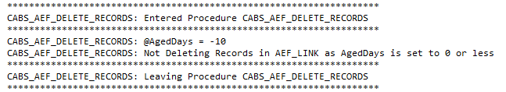
Figure 4 - AgedFunctionInDays Set To < 0 – No Records Deleted

AgedFuncionInDays Setting > 0
No | Test | Tester | Pass | Notes
1 | In section CABS_AUTO_EMAIL_FUNCS_Trigger  Add AgedFunctionInDays = 10 | TT
2 | Step through stored procedure CABS_AEF_DELETE_RECORDS | TT |  | Ensure that no records exist that have an AEFL_FDay value greater than AEFL_DAY + 10 days.

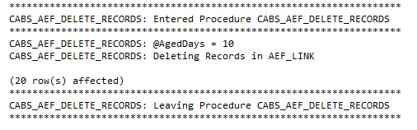
Figure 5 - AgedFunctionInDays Set To > 0 – Records Deleted

AgedFuncionInDays Setting > 0
No | Test | Tester | Pass | Notes
1
2 | Ensure records exist in AEF_LINK  SELECT COUNT(*) FROM AEF_Link | TT |  | Returned 53
2 | In stored procedure CABS_AEF_DELETE_RECORDS comment out line SELECT * FROM AEF_LINK … and Re-Instate DELETE AEF_LINK | TT
3 | Run SQL Schduled Job [CABS] Auto-Email AEF_LINK Delete | TT
4 | Ensure records exist in AEF_LINK are now reduced  SELECT COUNT(*) FROM AEF_Link | TT |  | Returned 33  All records in the table should have a date in AEFL_FDay which is newer than the test day minus the number of days set by AgedFunctionInDays

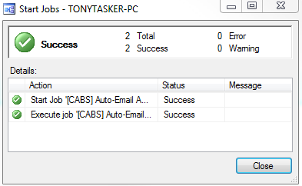
Figure 6 - AgedFunctionInDays Set To > 0 – Records Actually Deleted

